# Interface Design

User interface (UI) design aims to anticipate user needs and ensure that the interface's components are straightforward to use, find, and understand. As a result, we created the android-based user interface for the proposed system.

## Splash screen:



The above figure shows the splash screen of the system. It is the interface that appears as soon as the user or admin taps the app.

## Registration page

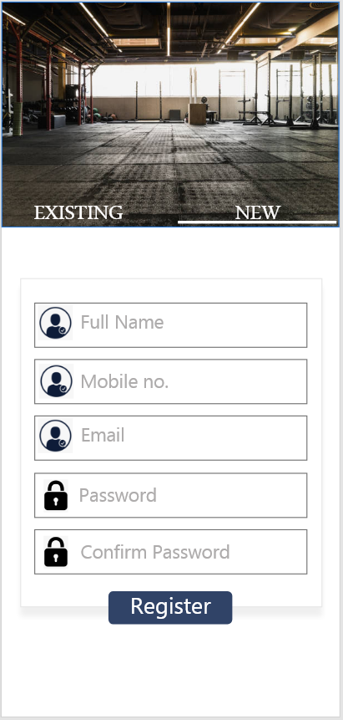

This is the registration page for the gym members of the proposed system to access the account.

## Login page

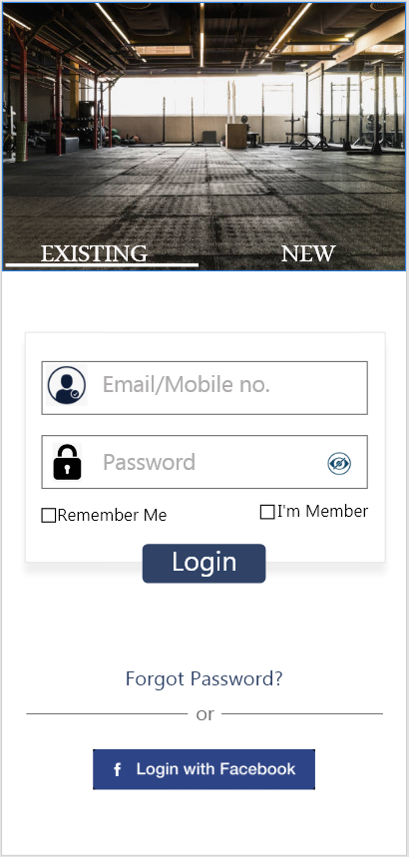

This page is login screen for the members of the gym to login the system which can be later accessed by the members inline or offline. They ca login with their registered main address or phone number and password set. Either they can easily login with Facebook.

## Dashboard

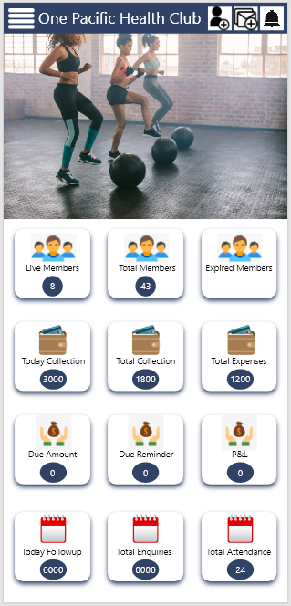

This dashboard screen shows the status of members, classes and account of the health club. This page appears different on admin and member page. Since the club wants to keep track of the instructors, members, classes and accounts this page gives daily brief status of the health club.

## Main menu

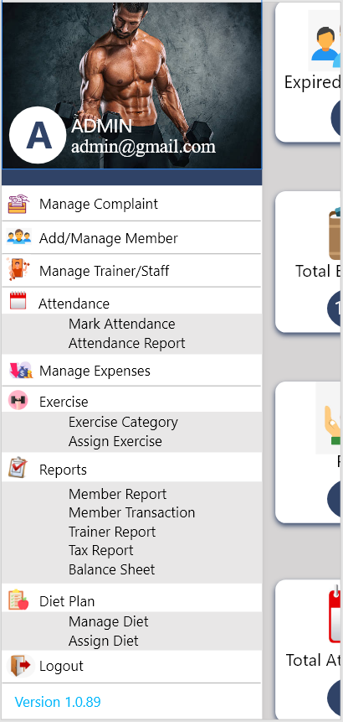

This main menu screen shows the menu features for the manager to manage the entire operation of the health club. It has features such as manage complaint or feedback, add or manage member, manage trainer or staff, marking attendance and generating attendance report, manage expenses, manage exercise, reports, diet plan, etc.

## Add member

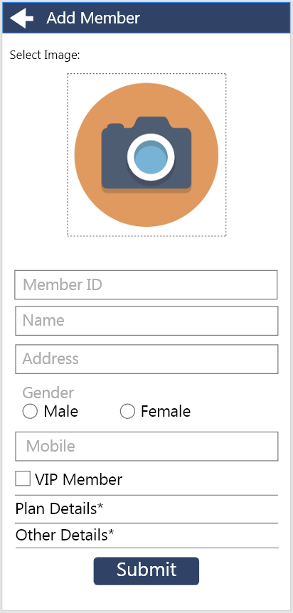

This page allows the admin or manager to add member to the gym. Here plan details include class, instructor, fee and due details of the member and other details include ID proof, documents and other personal details.

## Feedback

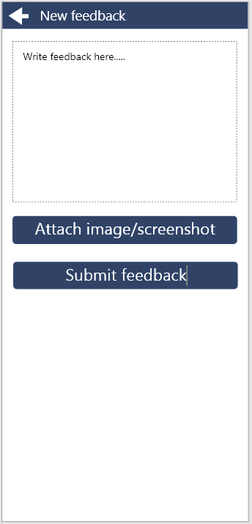

If a user wants to give feedback on the system of the club, they can attach image or screenshot of the system. The appears as shown above.

## 

## Payment

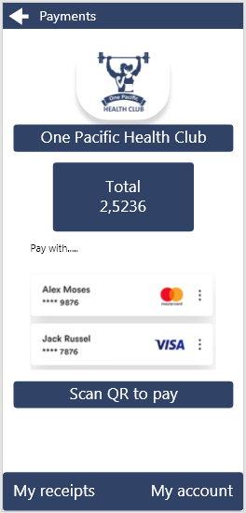

A member of the health club can make payment cashless with the system. They can easily pay through mobile banking. It has feature to scan QR code to proceed payment.

## Receipt

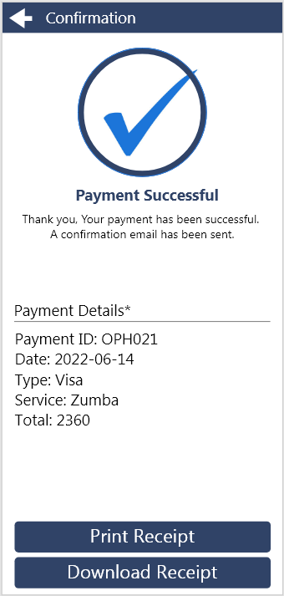

A member gets confirmation and online receipt for their payment. They can either download or print the receipt.

## Schedule

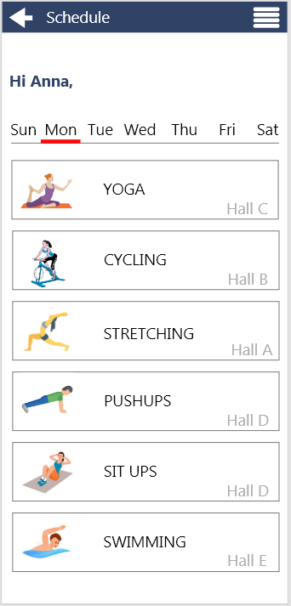

A member can view their exercise schedule and assigned exercise in schedule page. An admin cam assign exercise to member and instructor. They can view types of exercise, type and room to conduct respective exercises.